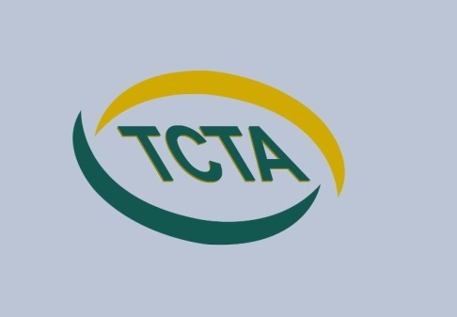
Thanet Community Transport Association (TCTA)
Policies & Procedures

Date created:-1st October 2015 | Date reviewed:- 29th November 2019
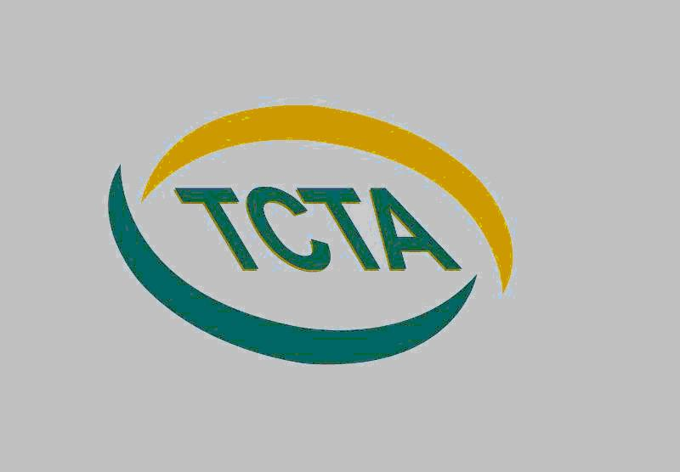
Amended 20th October 2020

Compliments & complaints policy & procedure
We view complaints as an opportunity to learn and improve for the future, as well as a chance to put things right for whom the complaint was made by.

Our policy is:
- To provide a fair complaints procedure which is clear and easy to use for anyone wishing to make a complaint
- To make sure all complaints are investigated fairly and in a timely way.
- To make sure that complaints are, wherever possible, resolved and that relationships are repaired.
- To gather information which helps us to improve what we do
Definition of a Complaint
A complaint is any expression of dissatisfaction, whether justified or not, about any aspect of our service we provide.
Where Complaints Come From
Complaints may come from a parent, carer, school, and a passenger, members of the public, social services, KCC or other professional bodies. A complaint can be received verbally, by phone, by email or in writing.
Confidentiality
All complaint information will be handled sensitively, telling only those who need to know and following our confidentiality policy.
Making a complaint
All complaints should be made to the manager who will investigate and manage the complaint. If you cannot go to the manager, you can go to another manager at this stage.

Making a compliment/positive feedback
We pride ourselves on our helpful and polite attitude and aim to provide a friendly and efficient service. We would much appreciate any feedback, good or bad. You can do this in writing, telephone, email or social media and we will always aim to pass on feedback to all of our staff.

